TASK – 2

# TARGET:-

* **TARGET DOMAINS :-**

1. <https://buruniv.ac.in/>
2. <https://stjosephsvizag.com/>
3. <https://gnauniversity.edu.in/>
4. <https://hindusthan.net/>
5. <http://coer.ac.in/>

## QUESTION-1 :-

**Find admin login pages in the given websites using footprinting techniques (URL).**

## QUESTION-2 :-

1. **Gather 10 email addresses from any 3 given domains. Note: Domain/sub domain registered email IDs only.**
2. **Find whether the mails have been breached and if breached provide the resource(download link) where you can get the database file**.

## QUESTION-3 :-

**Find 7 webcams which are connected in the open network and are live streaming i.e, when accessed you should be able to watch the live**

**streaming(URL).**

**Note: All the webcams should be from one country only.**

# SYNOPSIS:-

Google dork is a search query. This uses advanced searching operations to find information that is not automatically available on a website. Google dorking is a passive attach that involves the use of custom code. Google dorking is also known as google hacking. It can return information difficult to locate through simple search queries.

# TECHNICAL PROCEDURE :-

## SOLUTION-1 :-

**ADMIN LOGIN PAGES :-**

**TOOL USED:- “** GOOGLE DORKS **”**

### Step-1:

Open google chrome.

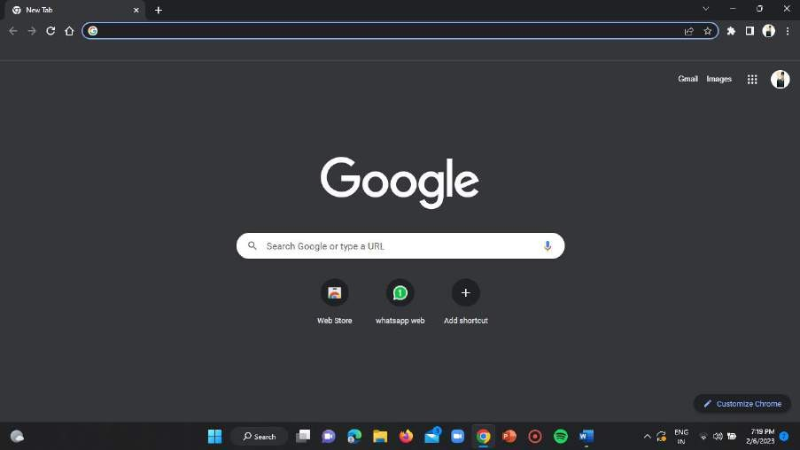

### Step-2:

Open incognito window in your google manually or by using the below mentioned shortcut.

SHORTCUT = “ ctrl+shift+n ”

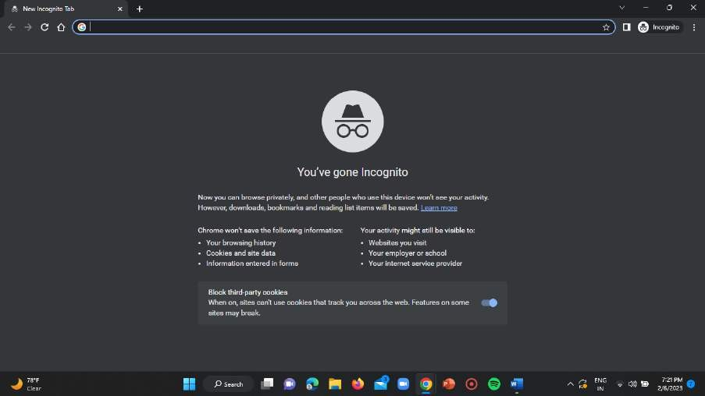

### Step-3:

Start using several google dorks regarding the admin login page details.

## DOMAIN-1:

### Step-4:

Use the “admin” dork for the very first domain. That is type “ https://buruniv.ac.in admin ”

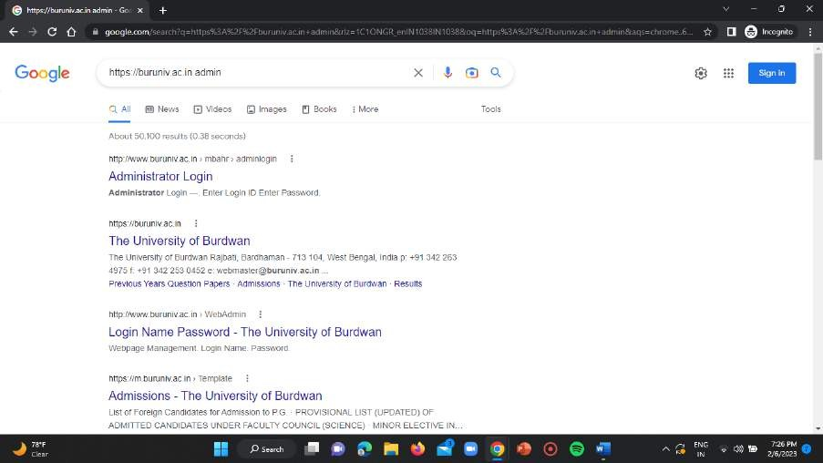

### Step-5:

Now click on the very first blue link displayed on the home page is “Administrator login” page.

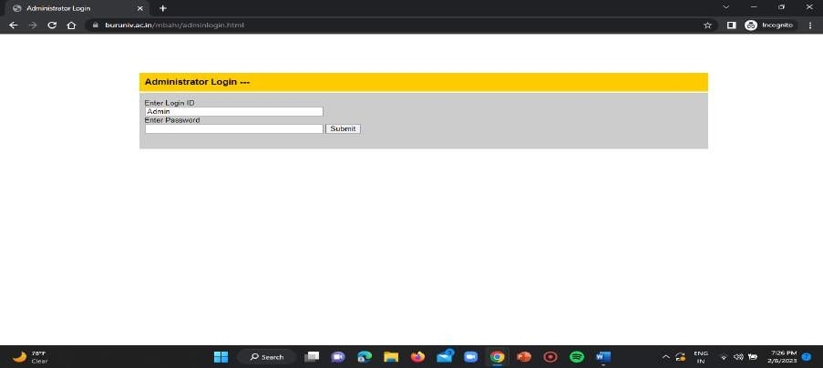

## ADMIN PAGE LINK FOR THE FIRST TARGET DOMAIN:

<https://www.buruniv.ac.in/mbahr/adminlogin.html>

## DOMAIN-2:

### Step-6:

In domain-2 use the google dork “site:stjosephsvizag.com login.php” and search it as it is in the search input section of the chrome page.

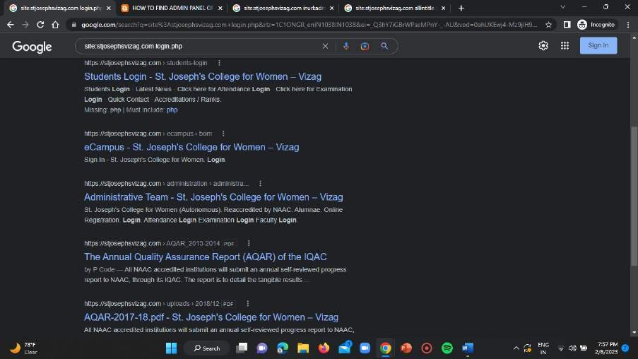

### Step-7:

Now click on the blue link mentioning as “administrative team”. The login page looks as follows.

## ADMIN LOGIN PAGE LINK FOR THE SECOND TARGET DOMAIN:

[https://stjosephsvizag.com/wp-](https://stjosephsvizag.com/wp-login.php?redirect_to=https%3A%2F%2Fstjosephsvizag.com%2Fwp-admin%2F&reauth=1)

[login.php?redirect_to=https%3A%2F%2Fstjosephsvizag.com%2Fwp-](https://stjosephsvizag.com/wp-login.php?redirect_to=https%3A%2F%2Fstjosephsvizag.com%2Fwp-admin%2F&reauth=1) [admin%2F&reauth=1](https://stjosephsvizag.com/wp-login.php?redirect_to=https%3A%2F%2Fstjosephsvizag.com%2Fwp-admin%2F&reauth=1)

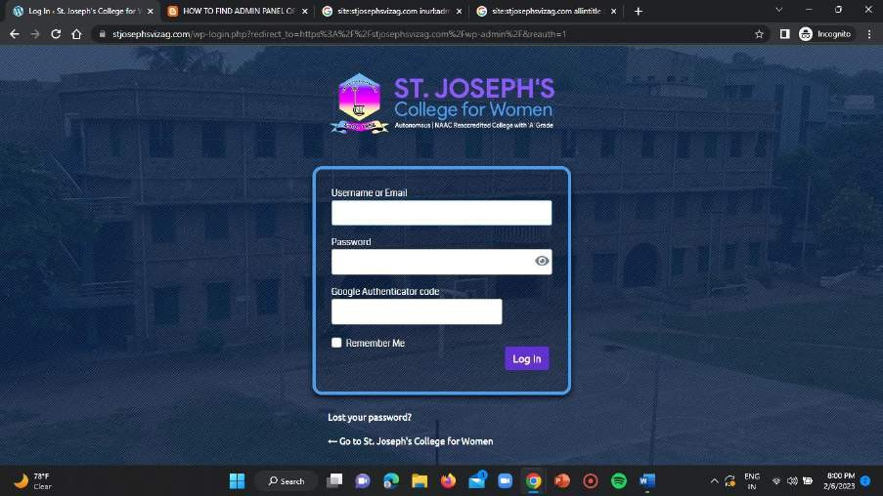

## DOMAIN-3:

### Step-8:

In case of domain-3 use the google dork “site:hindusthan.net inurl:admin”

i.e search it on your chrome browser and wait for the results.

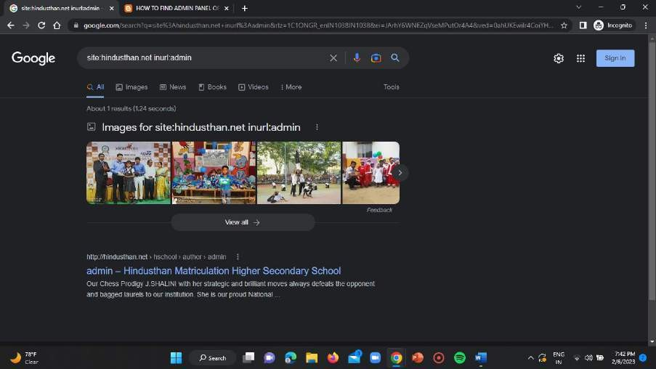

### Step-9:

Now click on the blue link mentioning as “admin” on the displayed result page after searching.

Then the required admin portal i.e login page gets opened as shown below.

## ADMIN LOGIN PAGE LINK FOR THE THIRD TARGET DOMAIN:

<https://hindusthan.net/wp-login.php>

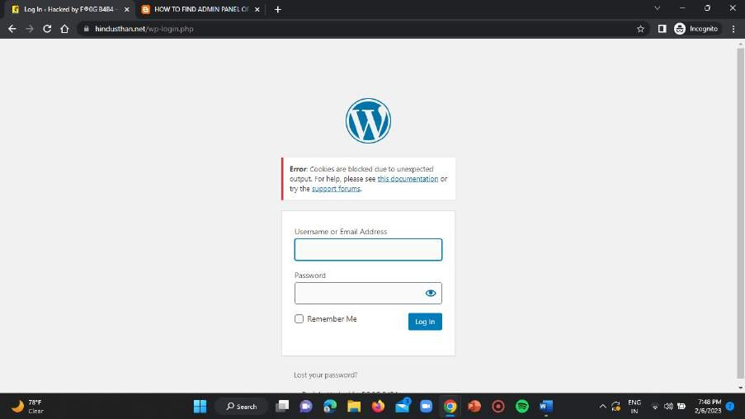

## DOMAIN-4:

### Step-10:

For this fourth target domain use the “inurl:admin” google dork and search it on the chrome window followed by the domain link i.e as “gnauniversity.edu.in inurl:admin” .

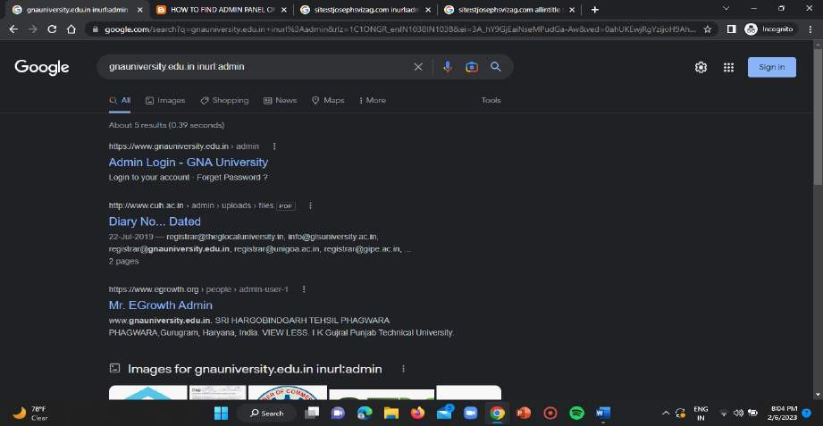

### Step-11:

Now open the blue link which is displayed as “Admin Login” in the above result page of the chrome.

## ADMIN LOGIN PAGE LINK FOR THE FOURTH TARGET DOMAIN:

<https://www.gnauniversity.edu.in/admin>

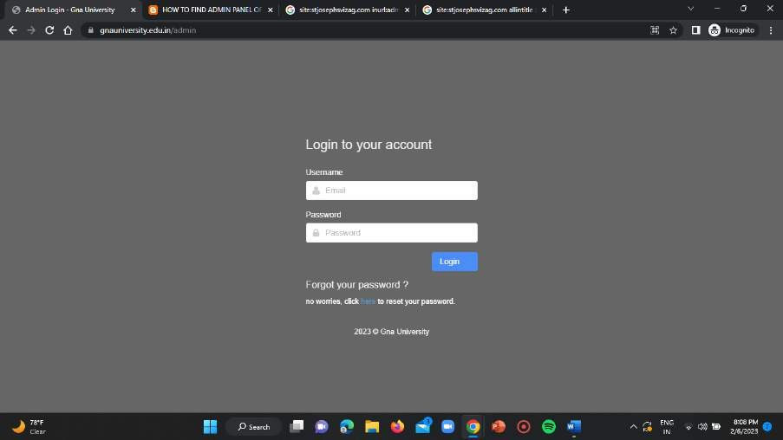

## DOMAIN-5:

### Step-12:

In case of fifth target domain use the “inurl:admin” google dork to obtain the admin login page for the target domain.

Search in the search bar as “site:coer.ac.in inurl:admin”

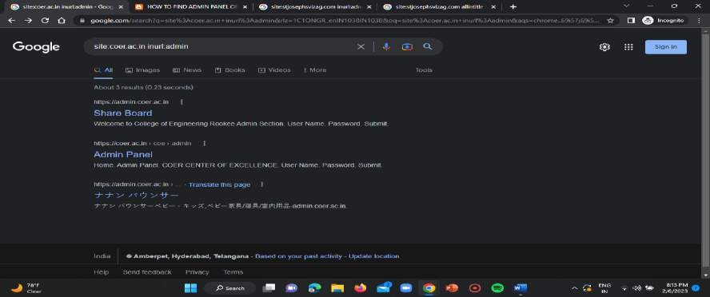

### Step-13:

Now click on the first blue link displaying as “Share board”.

## ADMIN LOGIN PAGE LINK FOR THE FIFTH TARGET DOMAIN:

<https://admin.coer.ac.in/>

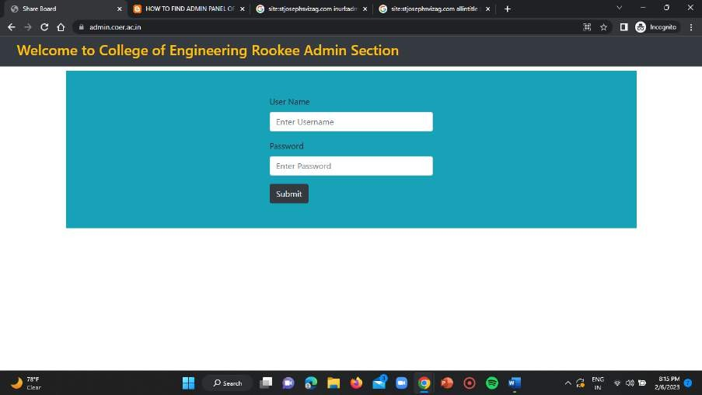

## SOLUTION-2 :- A-BIT :-

**TOOL USED = “** HUNTER.IO **” DOMAIN-1 :**

### Step-1:

Open your google chrome and search for the hunter.io webpage using the below mentioned link.

LINK: <https://hunter.io/>

**Note:** For appropriate and accurate results you need to signup using an

organisation/work email IDs i.e the college provided student accounts can also be used to create your accounts.

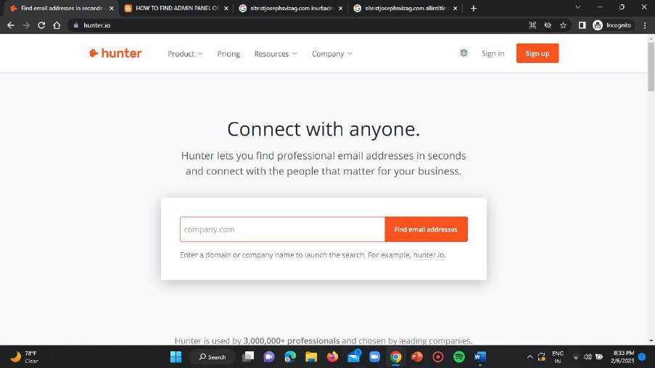

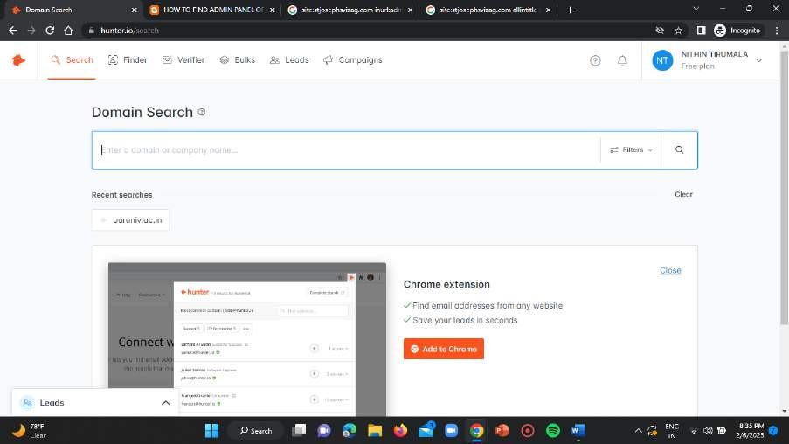

### Step-2:

Enter the target domain name in the input bar of the hunter.io homepage and click on enter key.

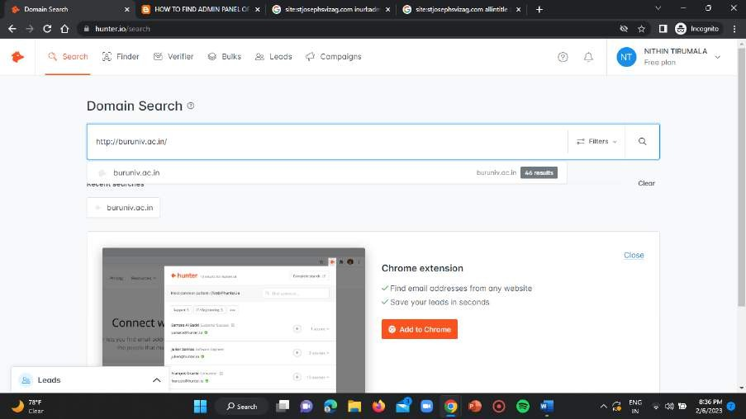

### Step-3:

The result displaying the various email addresses of the target domain will be displayed as shown below.

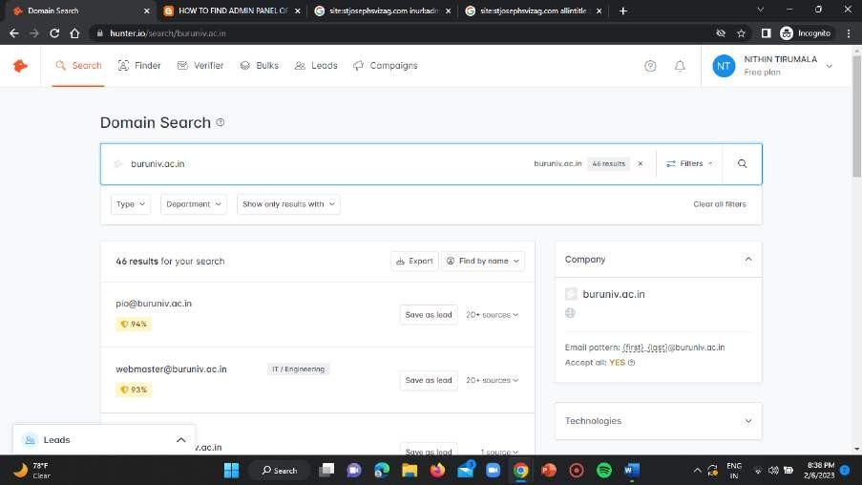

## E-MAIL ADDRESSES OF THE TARGET DOMAIN-1:

1. [pio@buruniv.ac.in](mailto:pio@buruniv.ac.in)
2. [webmaster@buruniv.ac.in](mailto:webmaster@buruniv.ac.in)
3. [dean_arts@buruniv.ac.in](mailto:dean_arts@buruniv.ac.in)
4. [registrar@buruniv.ac.in](mailto:registrar@buruniv.ac.in)
5. [info@buruniv.ac.in](mailto:info@buruniv.ac.in)
6. [rect.mba@buruniv.ac.in](mailto:rect.mba@buruniv.ac.in)
7. [rect.chemistry@buruniv.ac.in](mailto:rect.chemistry@buruniv.ac.in)
8. [rect.sanskrit@buruniv.ac.in](mailto:rect.sanskrit@buruniv.ac.in)
9. [rect.hindi@buruniv.ac.in](mailto:rect.hindi@buruniv.ac.in)
10. [rect.education@buruniv.ac.in](mailto:rect.education@buruniv.ac.in)

**STEP NOTE –** Similarly do the same thing i.e follow the same steps for all the domains.

## DOMAIN-4 :

### Step-5:

Give the target domain in the search bar of the hunter homepage and click on enter key.

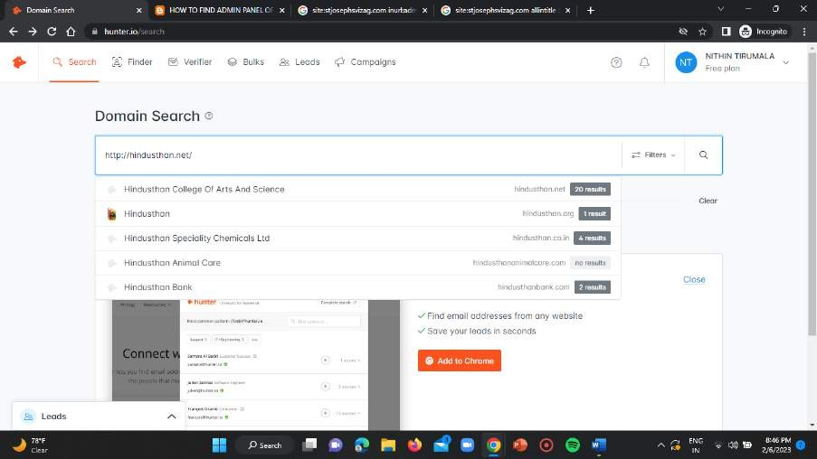

It results the page with the required email addresses of the target domain as follows.

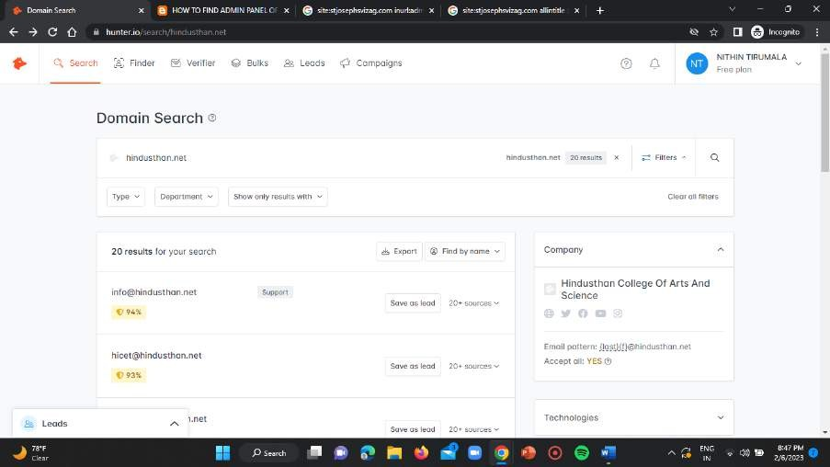

## E-MAIL ADDRESSES OF THE TARGET DOMAIN-4:

1. [info@hindusthan.net](mailto:info@hindusthan.net)
2. [hicet@hindusthan.net](mailto:hicet@hindusthan.net)
3. [hitech@hindusthan.net](mailto:hitech@hindusthan.net)
4. [hitprincipal@hindusthan.net](mailto:hitprincipal@hindusthan.net)
5. [hicas@hindusthan.net](mailto:hicas@hindusthan.net)
6. [barch@hindusthan.net](mailto:barch@hindusthan.net)
7. [school@hindusthan.net](mailto:school@hindusthan.net)
8. [admission@hindusthan.net](mailto:admission@hindusthan.net)
9. [ecampus@hindusthan.net](mailto:ecampus@hindusthan.net)
10. [bed@hindusthan.net](mailto:bed@hindusthan.net)

## DOMAIN-3 :

### Step-6:

Enter the target domain in the search input bar of the hunter homepage.

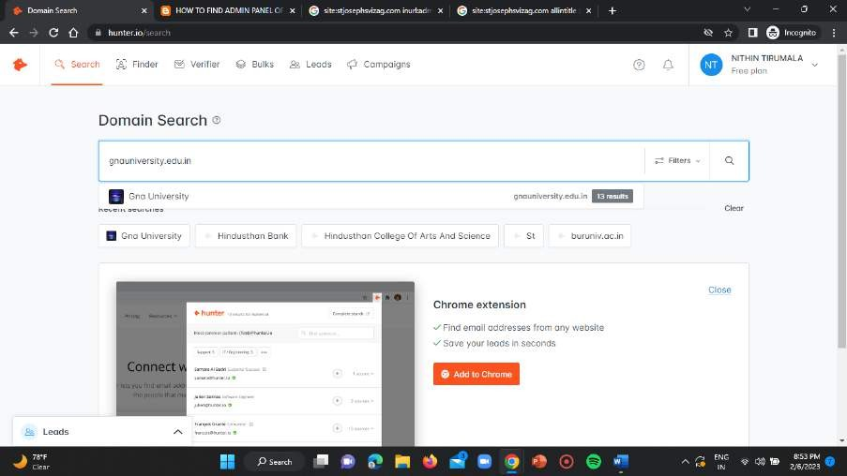

It results the page with the required email addresses of the target domain as follows.

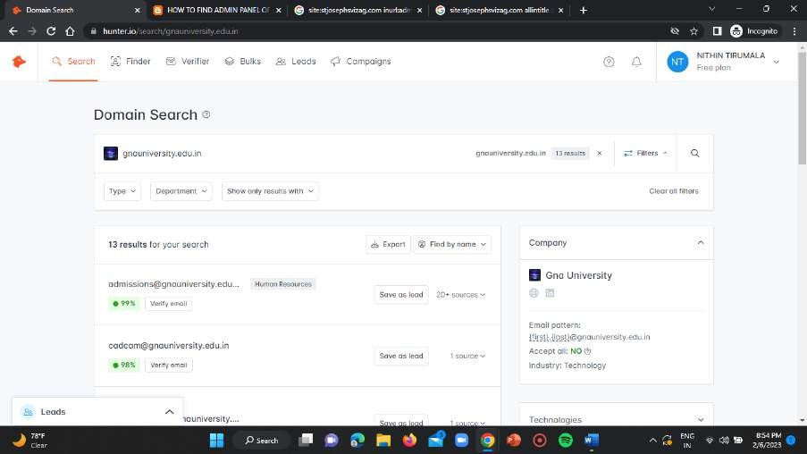

## E-MAIL ADDRESSES OF THE TARGET DOMAIN-3:

1. [admissions@gnauniversity.edu.in](mailto:admissions@gnauniversity.edu.in)
2. [cadcam@gnauniversity.edu.in](mailto:cadcam@gnauniversity.edu.in)
3. [sushant.anand@gnauniversity.edu.in](mailto:sushant.anand@gnauniversity.edu.in)
4. [parveen.singh@gnauniversity.edu.in](mailto:parveen.singh@gnauniversity.edu.in)
5. [info@gnauniversity.edu.in](mailto:info@gnauniversity.edu.in)
6. [icohost@gnauniversity.edu.in](mailto:icohost@gnauniversity.edu.in)
7. [iso@gnauniversity.edu.in](mailto:iso@gnauniversity.edu.in)
8. [research@gnauniversity.edu.in](mailto:research@gnauniversity.edu.in)
9. [dean.foh@gnauniversity.edu.in](mailto:dean.foh@gnauniversity.edu.in)
10. [careers@gnauniversity.edu.in](mailto:careers@gnauniversity.edu.in)

## B – BIT:

**TOOL USED =** “HAVE I BEEN PWNED”

**Link for the tool =** <https://haveibeenpwned.com/>

### Step-1:

Open your chrome incognito window in the browser and enter the above mentioned URL to get the access of “have I been pwned” tool.

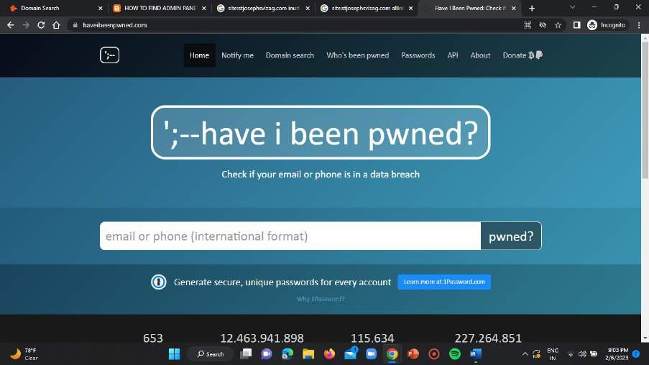

### Step-2:

Paste all the target email addresses that you have found in the above A-BIT solution of the target domains in the input bar of the have I been pwned

homepage to check whether the respective email addresses are breached are not.

**DATA BREACH VERIFICATION FOR ALL THE 30 EMAIL IDs :-**

1. [pio@buruniv.ac.in](mailto:pio@buruniv.ac.in)

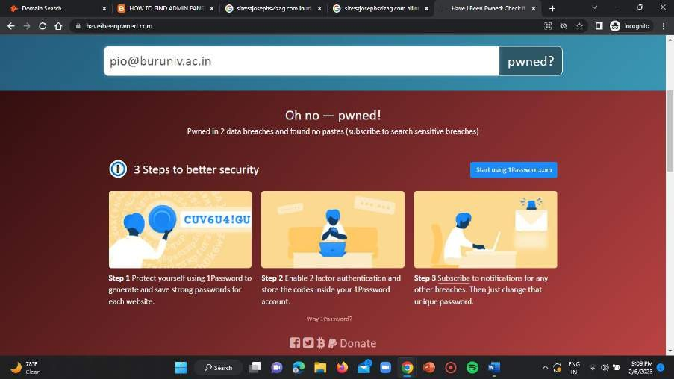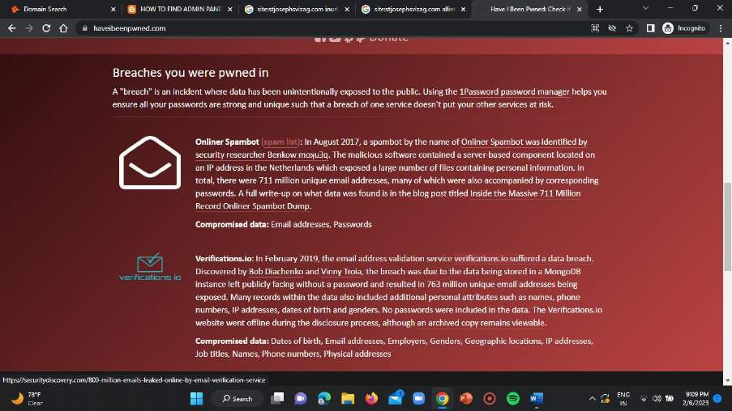

1. [webmaster@buruniv.ac.in](mailto:webmaster@buruniv.ac.in)

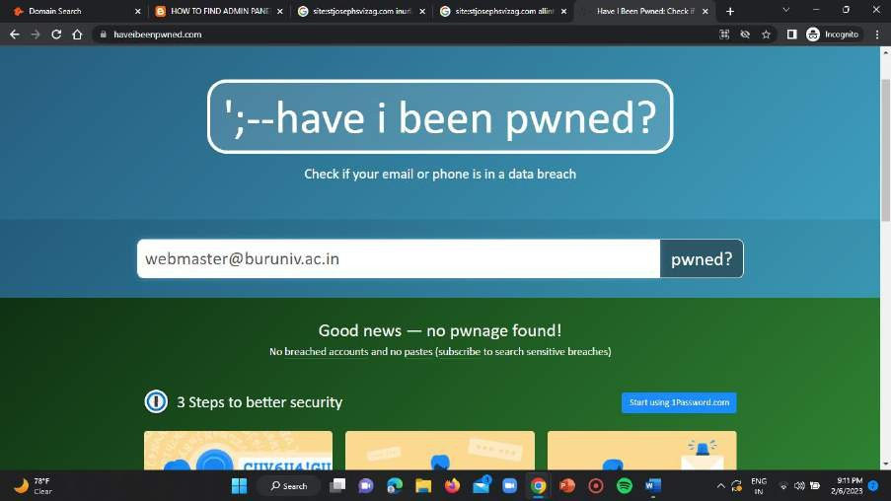

1. [dean_arts@buruniv.ac.in](mailto:dean_arts@buruniv.ac.in)

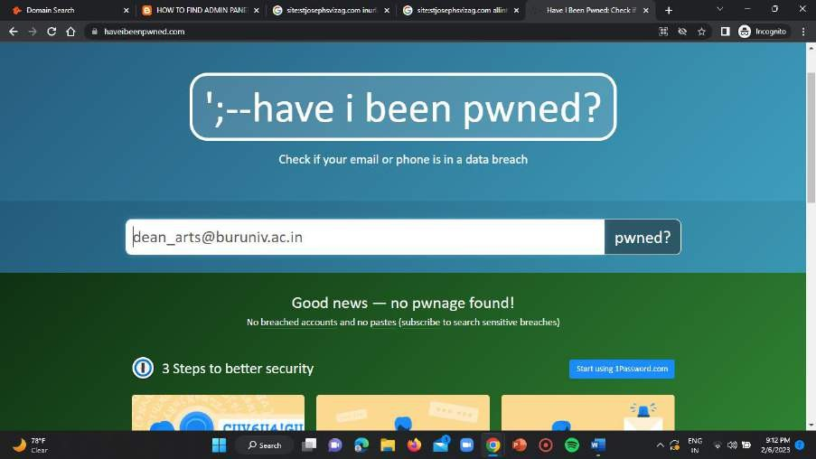

1. [registrar@buruniv.ac.in](mailto:registrar@buruniv.ac.in)

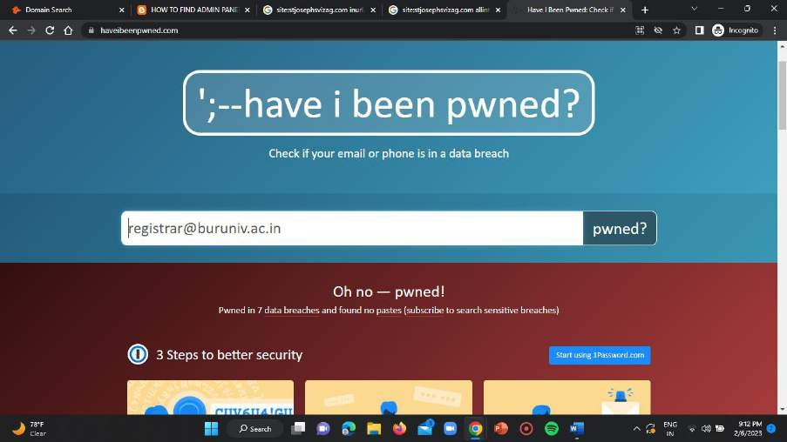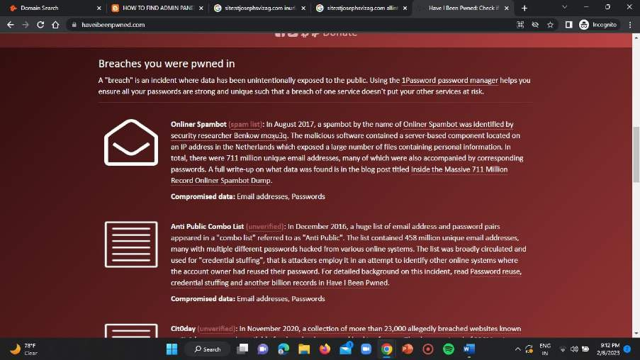

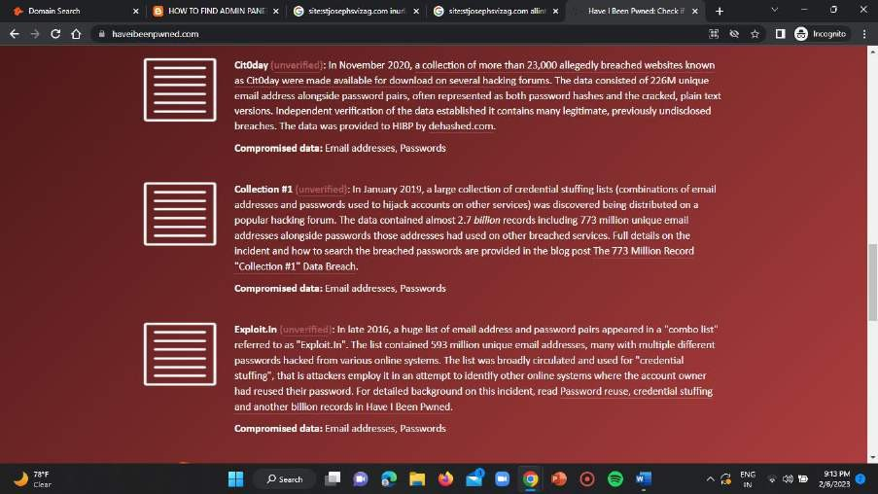

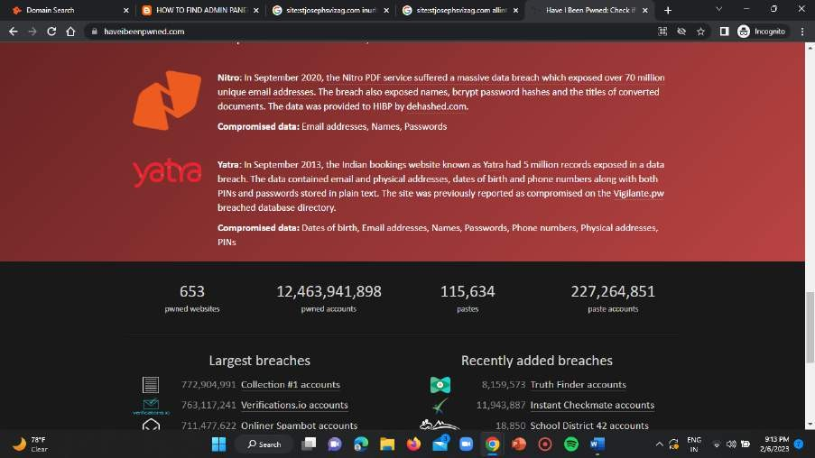

1. [info@buruniv.ac.in](mailto:info@buruniv.ac.in)

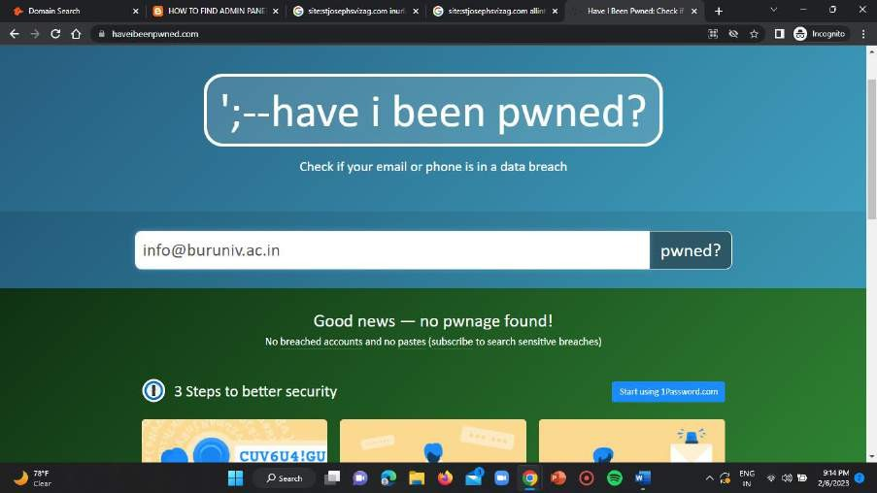

1. [rect.mba@buruniv.ac.in](mailto:rect.mba@buruniv.ac.in)

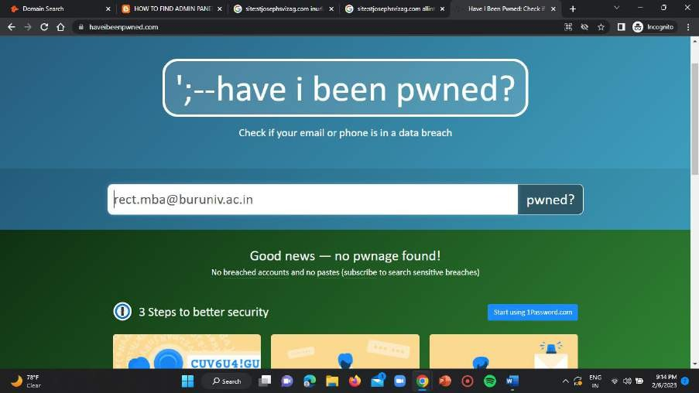

1. [rect.chemistry@buruniv.ac.in](mailto:rect.chemistry@buruniv.ac.in)

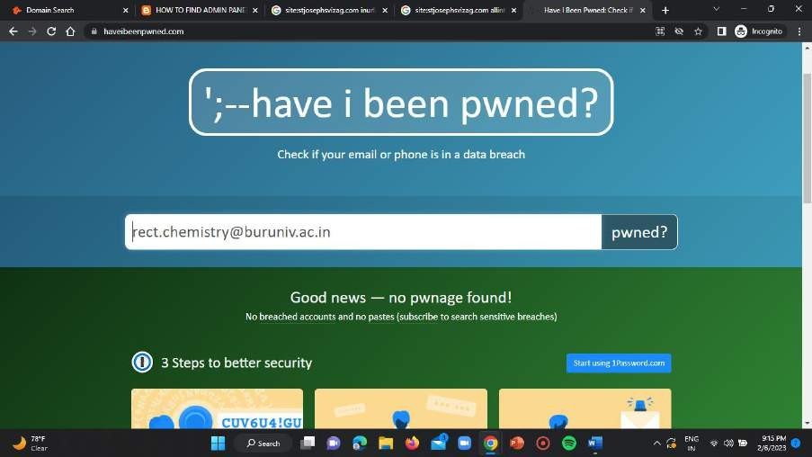

1. [rect.sanskrit@buruniv.ac.in](mailto:rect.sanskrit@buruniv.ac.in)

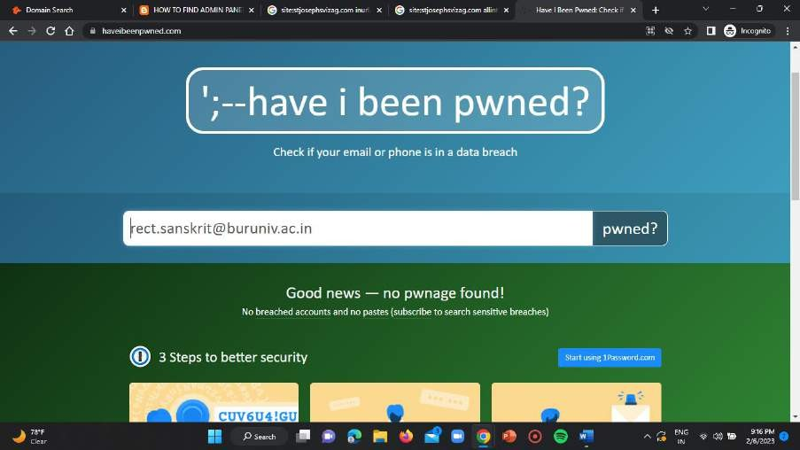

1. [rect.hindi@buruniv.ac.in](mailto:rect.hindi@buruniv.ac.in)

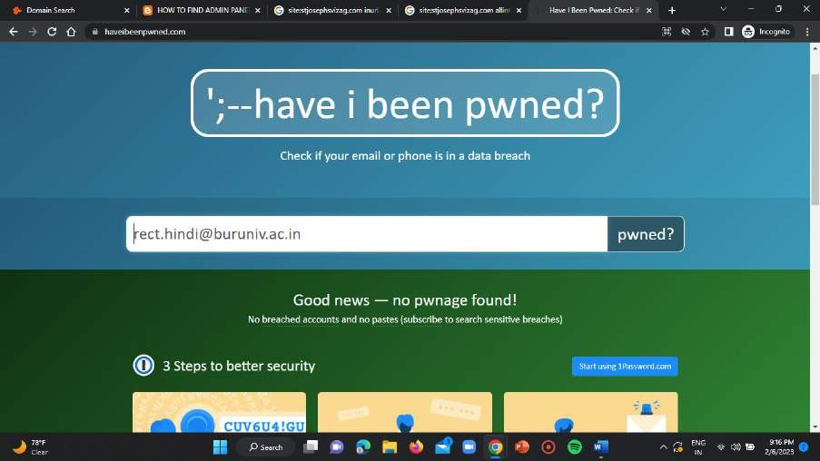

1. [rect.education@buruniv.ac.in](mailto:rect.education@buruniv.ac.in)

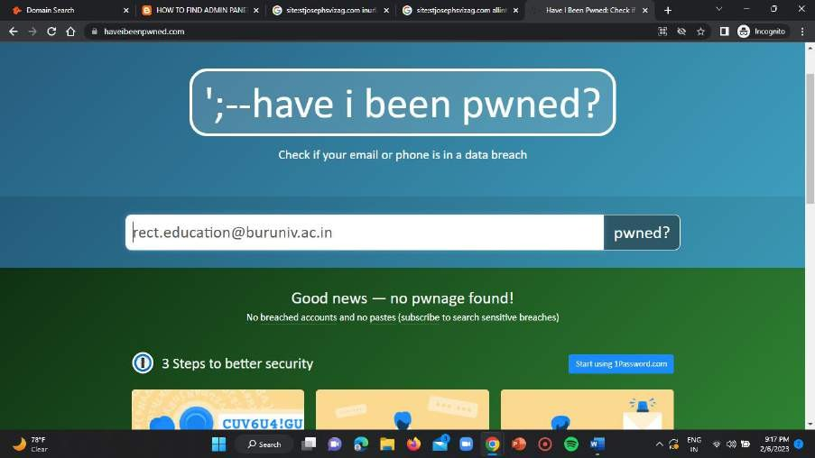

1. [info@hindusthan.net](mailto:info@hindusthan.net)

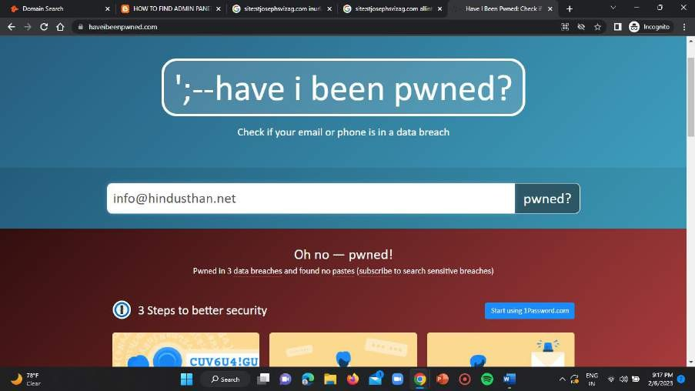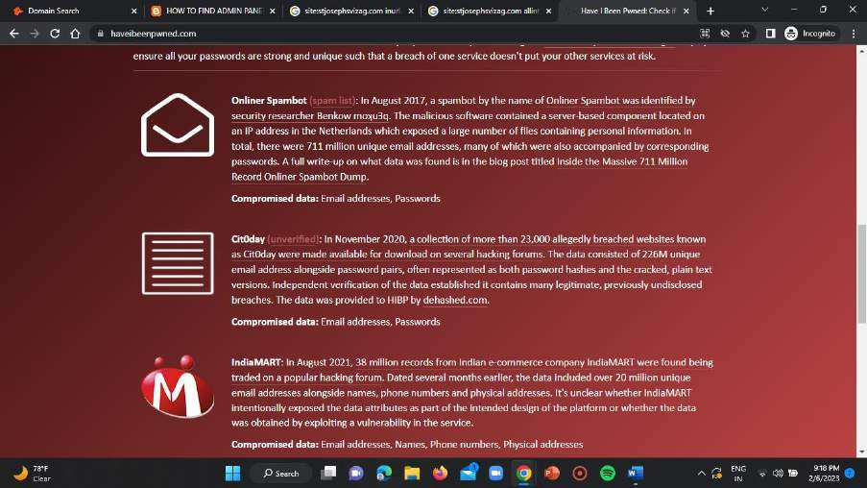

1. [hicet@hindusthan.net](mailto:hicet@hindusthan.net)

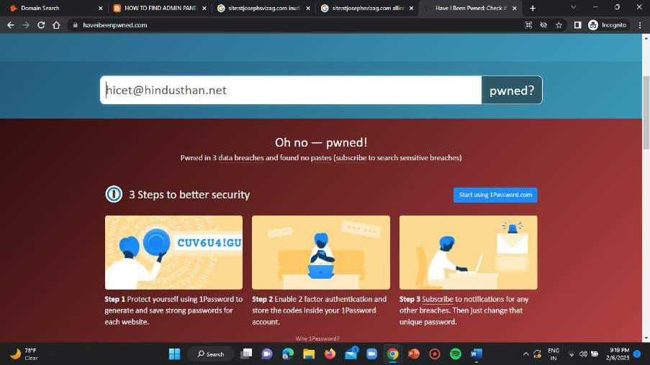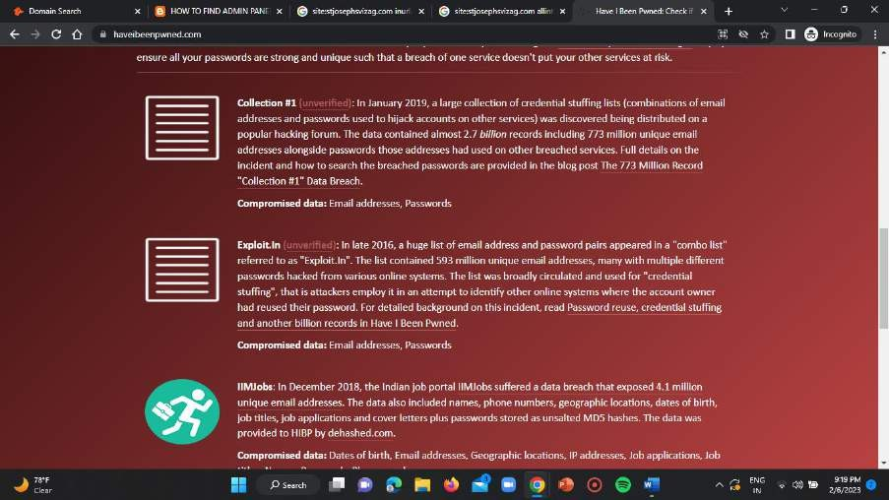

1. [hitech@hindusthan.net](mailto:hitech@hindusthan.net)

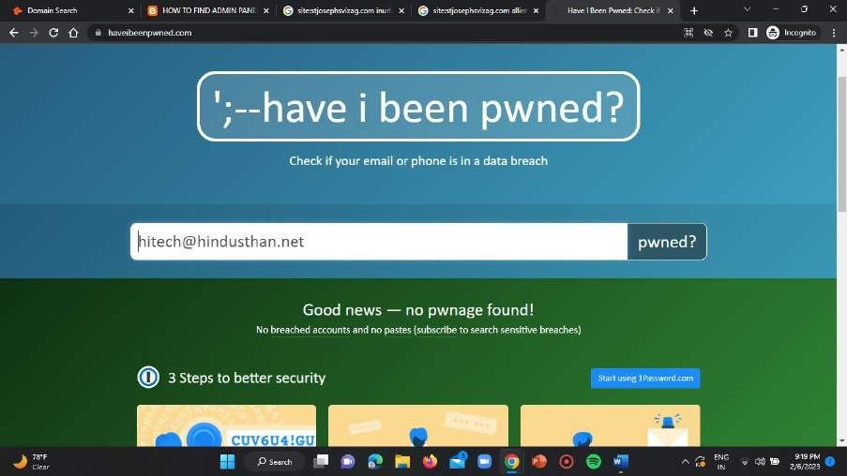

1. [hitprincipal@hindusthan.net](mailto:hitprincipal@hindusthan.net)

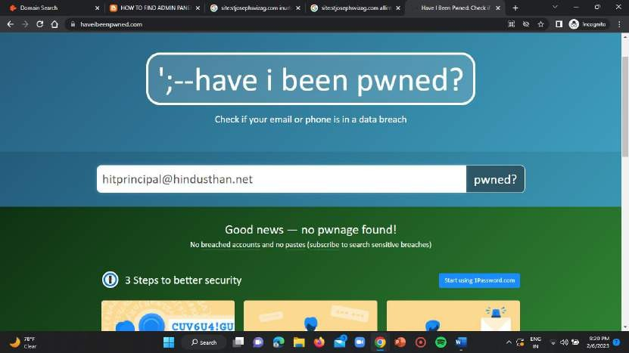

1. [hicas@hindusthan.net](mailto:hicas@hindusthan.net)

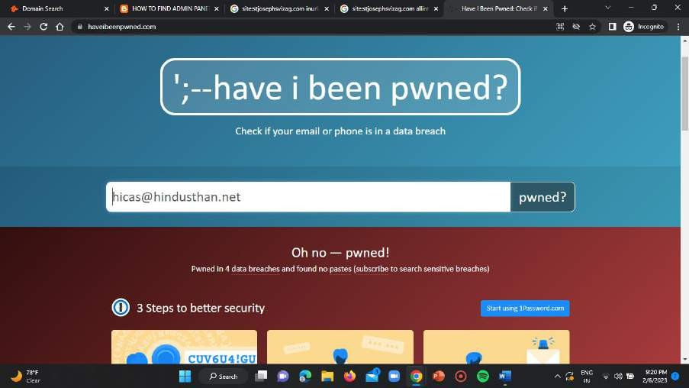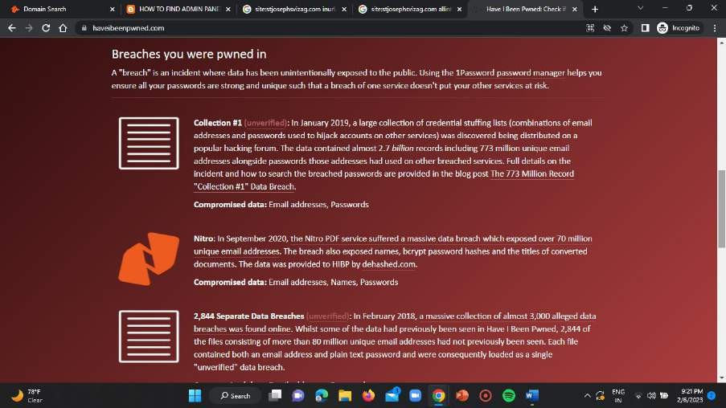

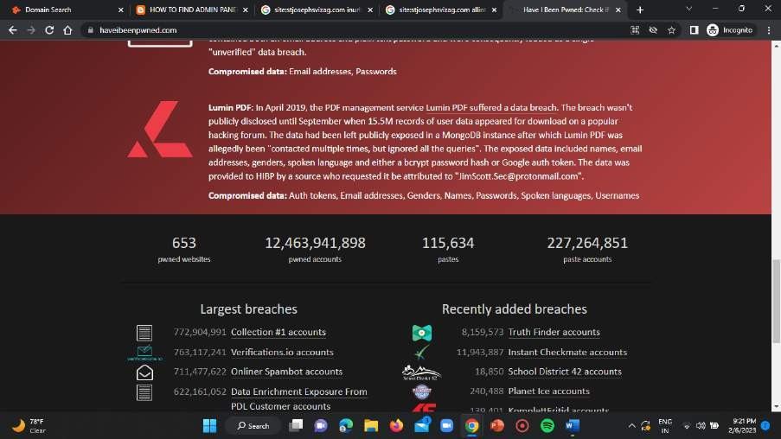

1. [barch@hindusthan.net](mailto:barch@hindusthan.net)

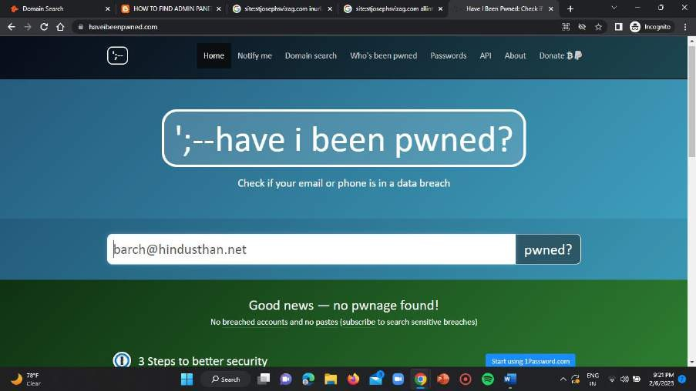

1. [school@hindusthan.net](mailto:school@hindusthan.net)

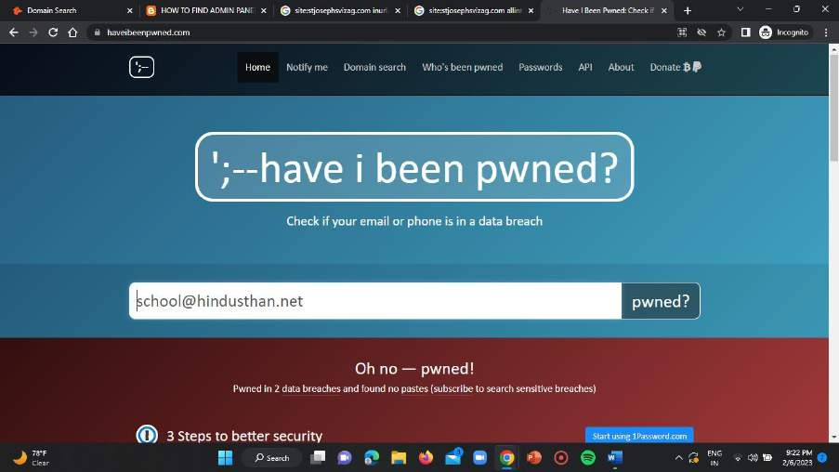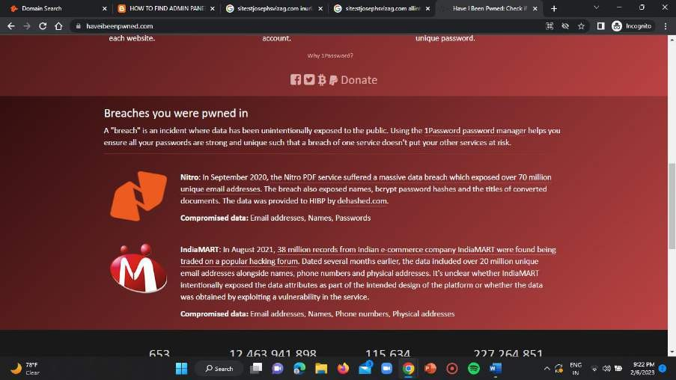

1. [admission@hindusthan.net](mailto:admission@hindusthan.net)

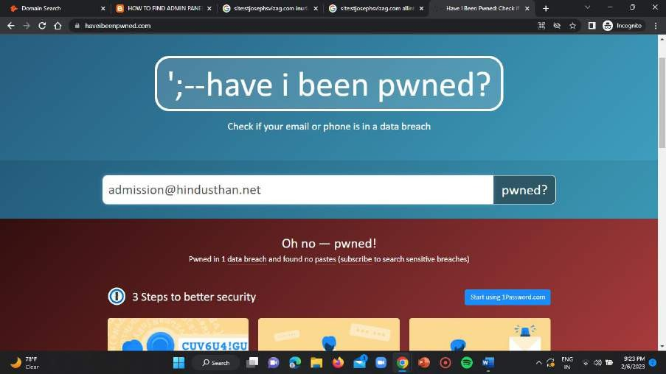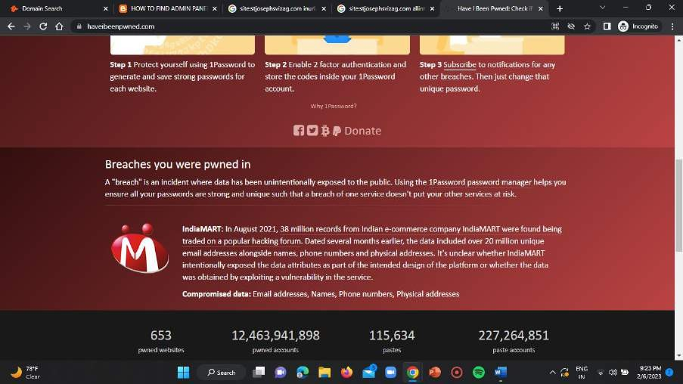

1. [ecampus@hindusthan.net](mailto:ecampus@hindusthan.net)

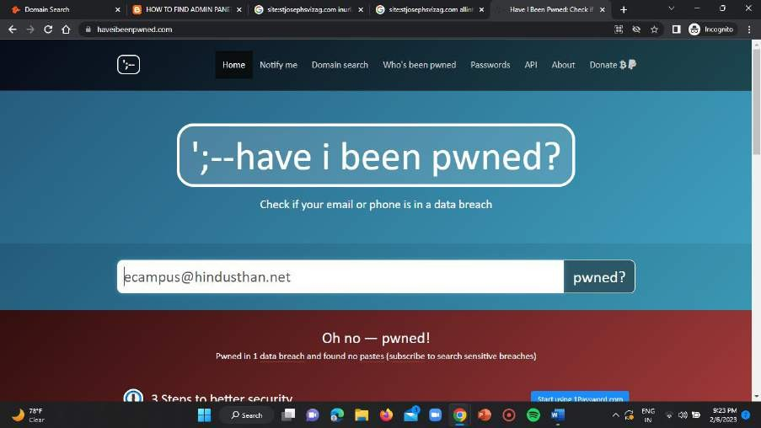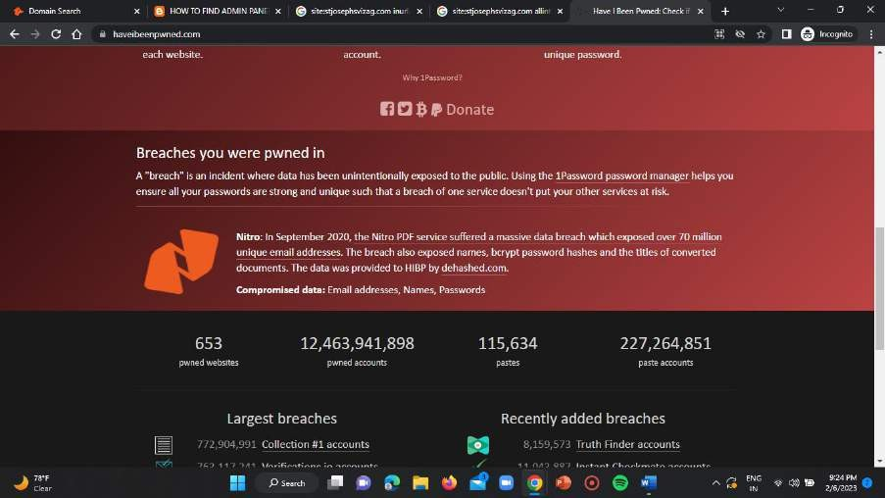

1. [bed@hindusthan.net](mailto:bed@hindusthan.net)

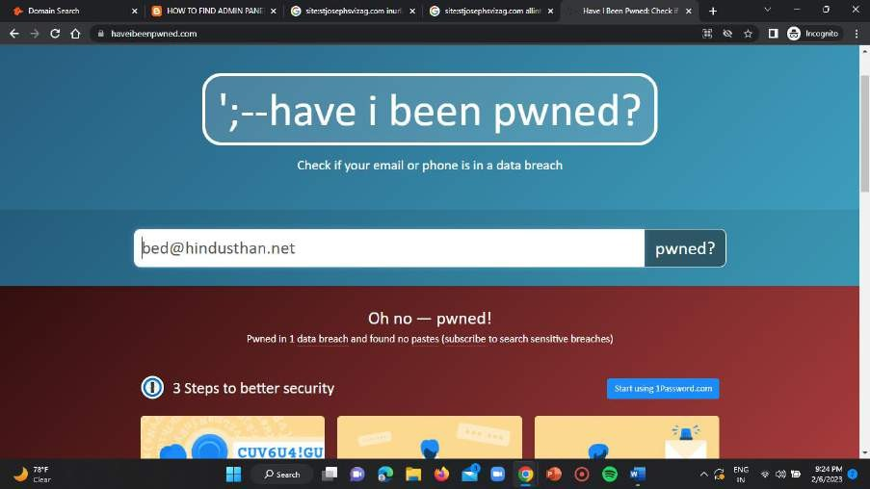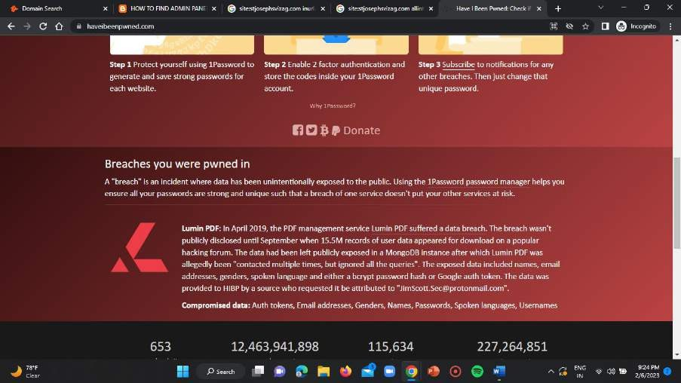

1. [admissions@gnauniversity.edu.in](mailto:admissions@gnauniversity.edu.in)

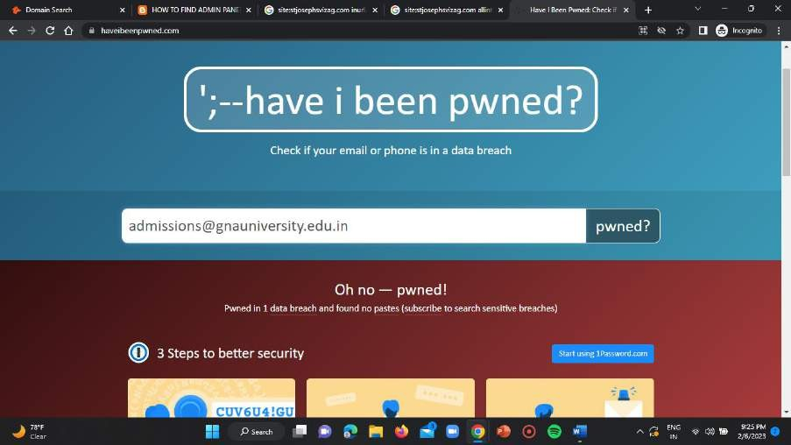

1. [cadcam@gnauniversity.edu.in](mailto:cadcam@gnauniversity.edu.in)

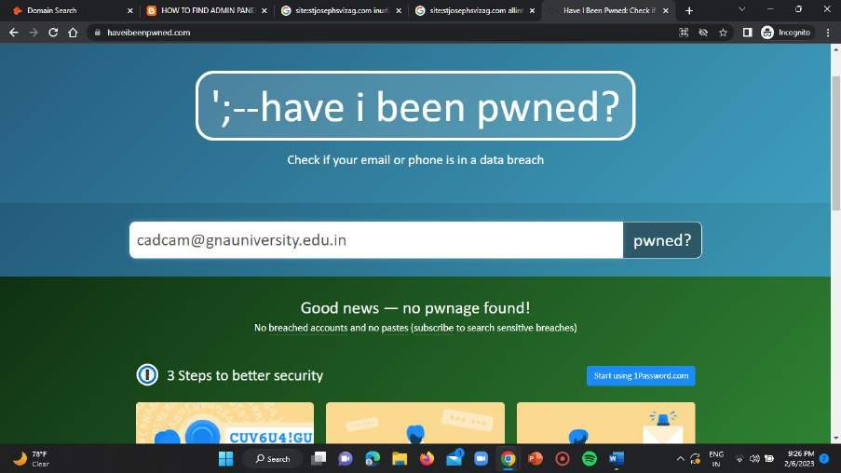

1. [sushant.anand@gnauniversity.edu.in](mailto:sushant.anand@gnauniversity.edu.in)

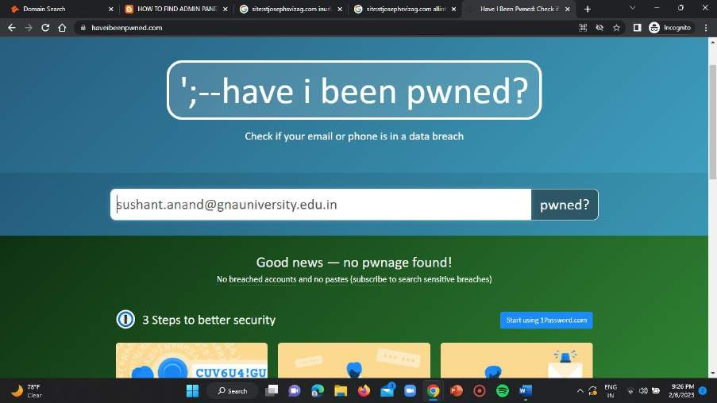

1. [parveen.singh@gnauniversity.edu.in](mailto:parveen.singh@gnauniversity.edu.in)

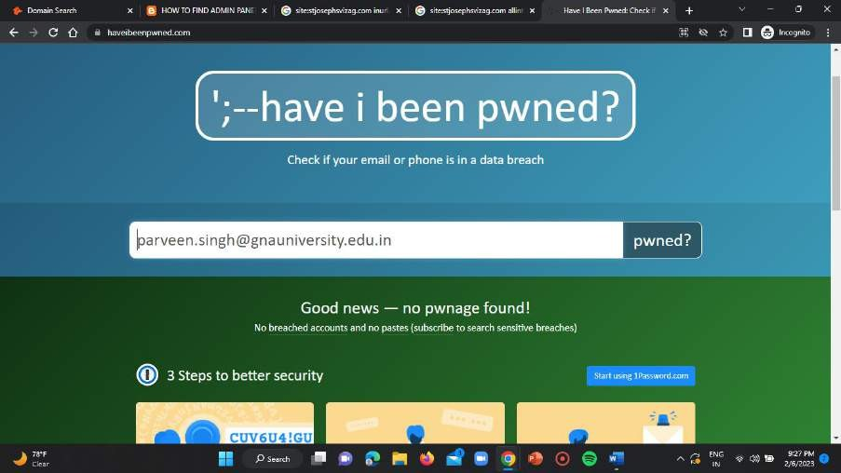

1. [info@gnauniversity.edu.in](mailto:info@gnauniversity.edu.in)

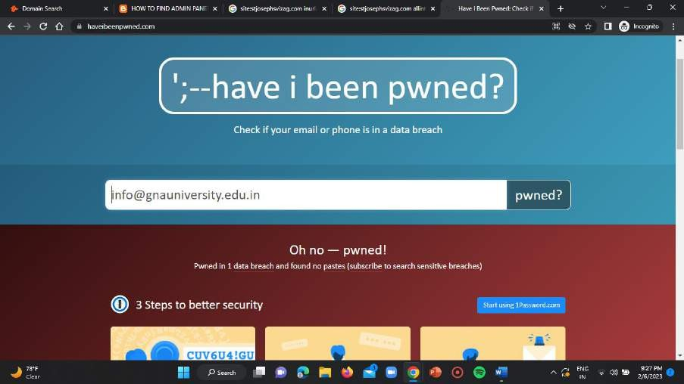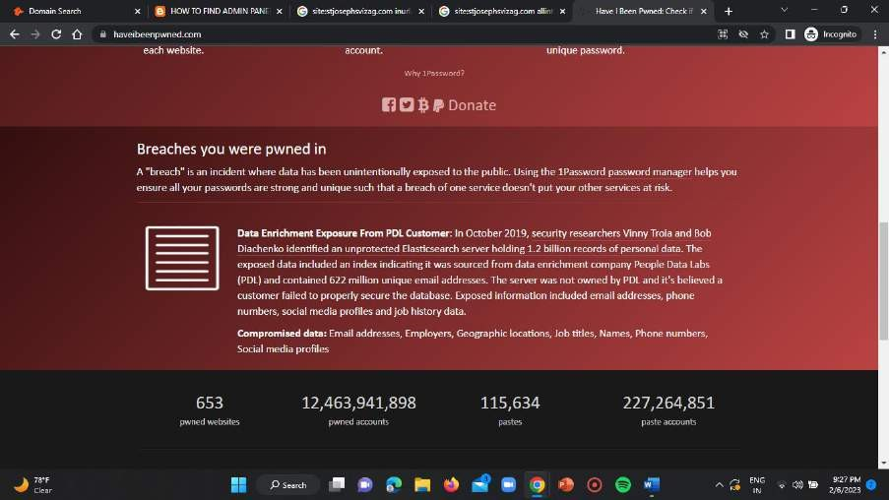

1. [icohost@gnauniversity.edu.in](mailto:icohost@gnauniversity.edu.in)

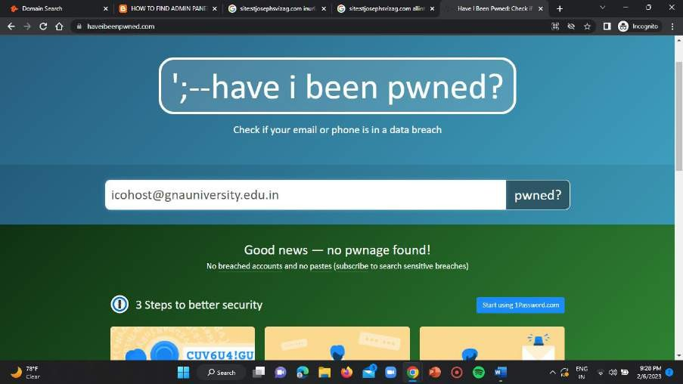

1. [iso@gnauniversity.edu.in](mailto:iso@gnauniversity.edu.in)

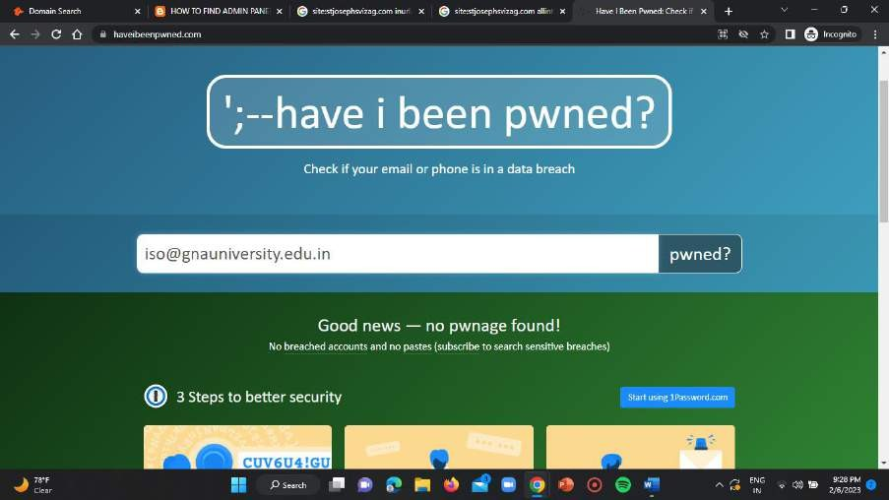

1. [research@gnauniversity.edu.in](mailto:research@gnauniversity.edu.in)

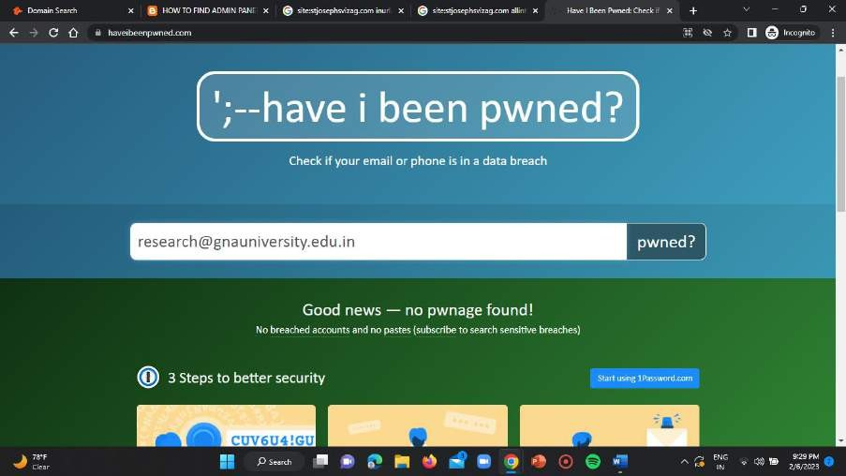

1. [dean.foh@gnauniversity.edu.in](mailto:dean.foh@gnauniversity.edu.in)

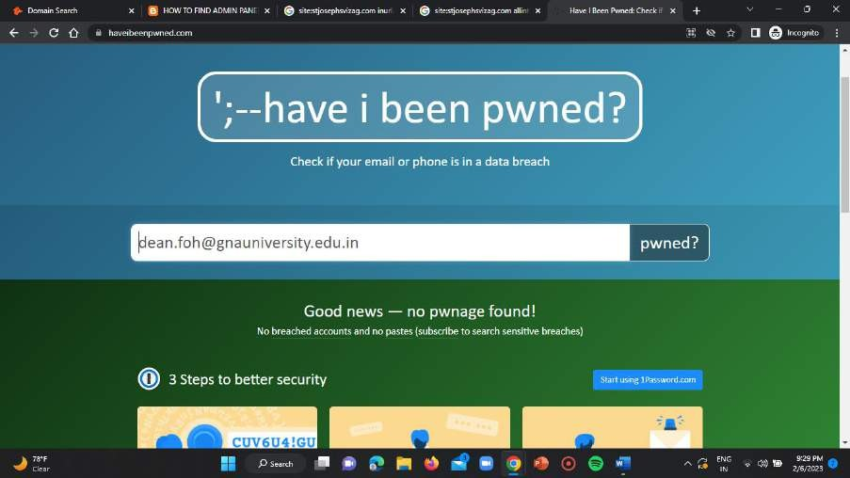

1. [careers@gnauniversity.edu.in](mailto:careers@gnauniversity.edu.in)

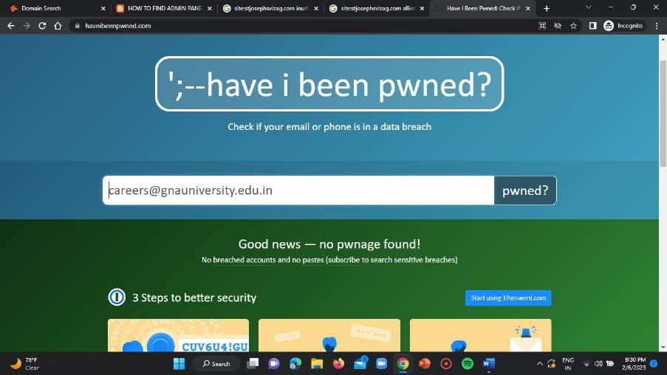

## SOLUTION-3 :-

**WEB CAMS WHICH ARE CONNECTED IN PUBLIC NETWORK AND WHICH ARE ALSO FROM A SINGLE COUNTRY:**

### Step-1:

Open the incognito chrome window in your web browser and use the google dork “inurl:livecam” and enter it in the search input bar of the homepage.

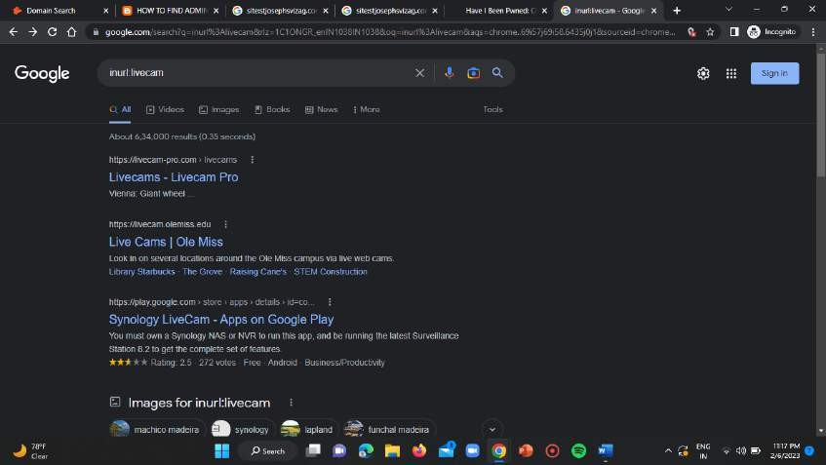

### Step-2:

Open the second blue link mentioning as “Live Cams | Ole Miss” then you get displayed all the publicly available live streaming cams.

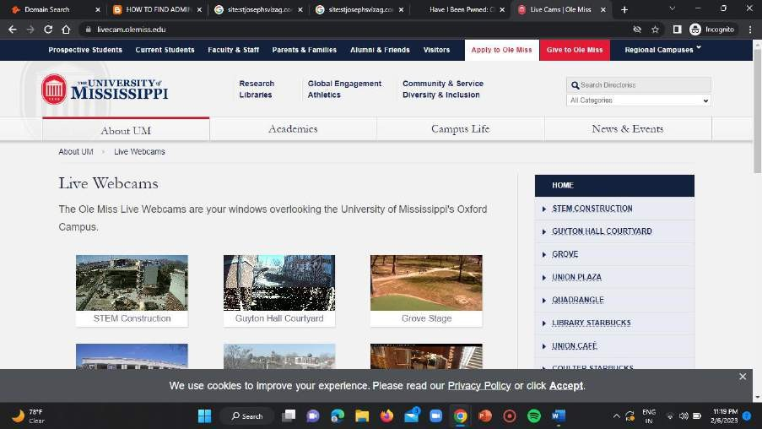

## CAM-1:

**LINK =** <https://livecam.olemiss.edu/stemeast/>

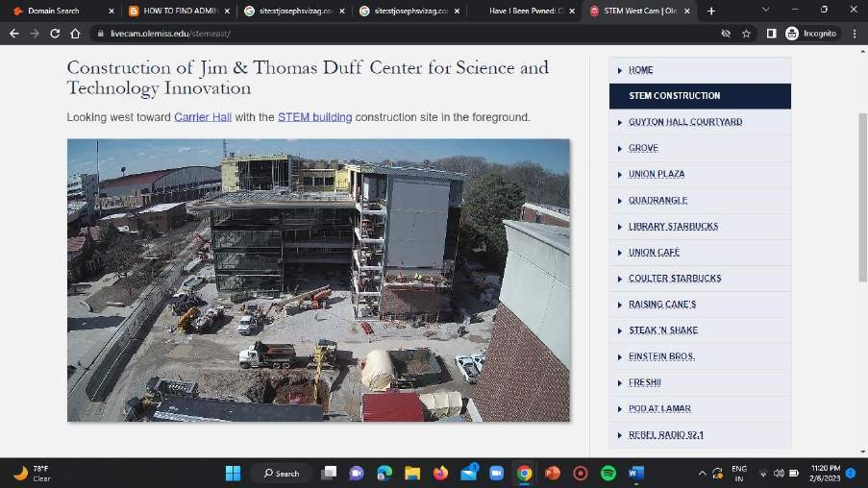

## CAM-2:

**LINK =** <https://livecam.olemiss.edu/guytonrear/>

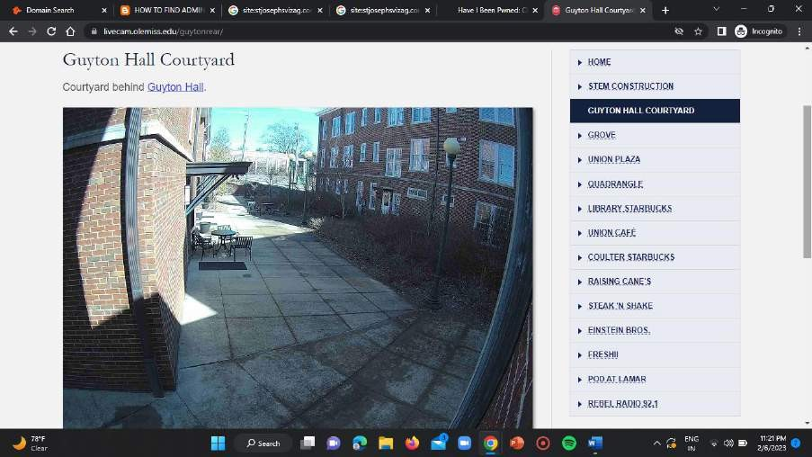

## CAM-3:

**LINK =** <https://livecam.olemiss.edu/grove/>

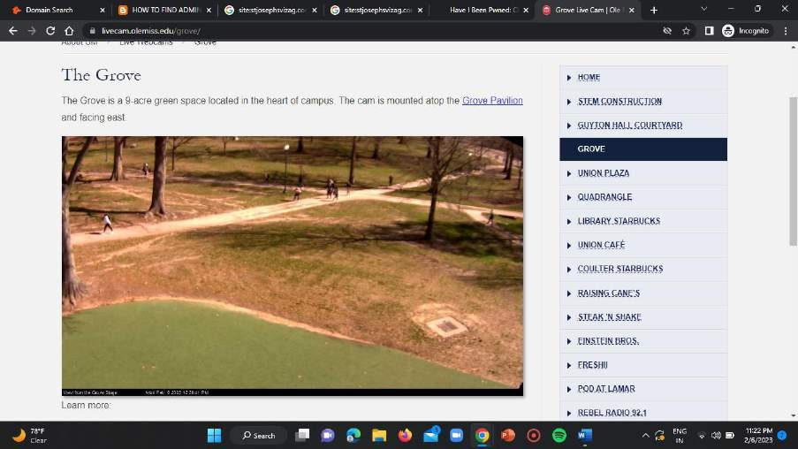

## CAM-4:

**LINK =** <https://livecam.olemiss.edu/unionplaza/>

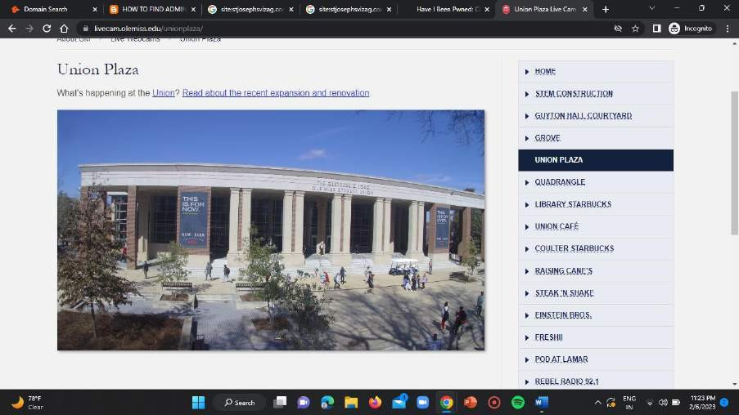

## CAM-5:

**LINK =** <https://livecam.olemiss.edu/coffee/>

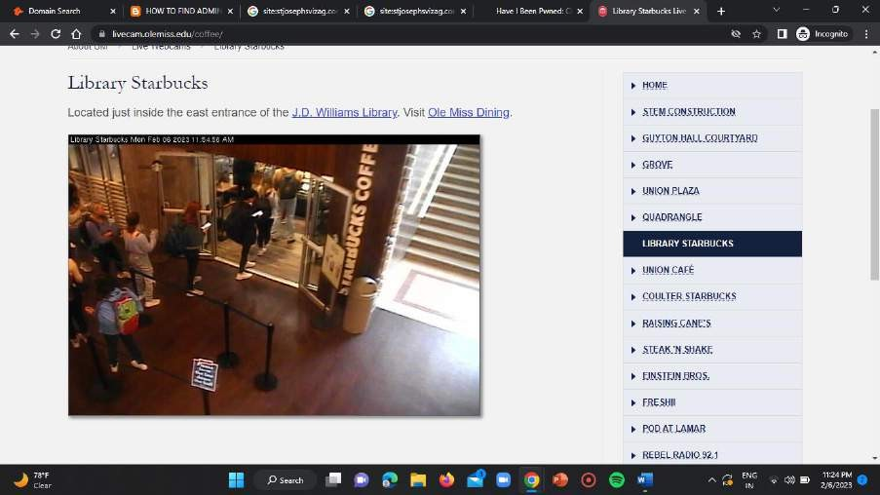

## CAM-6:

**LINK =** <https://livecam.olemiss.edu/unioncafe/>

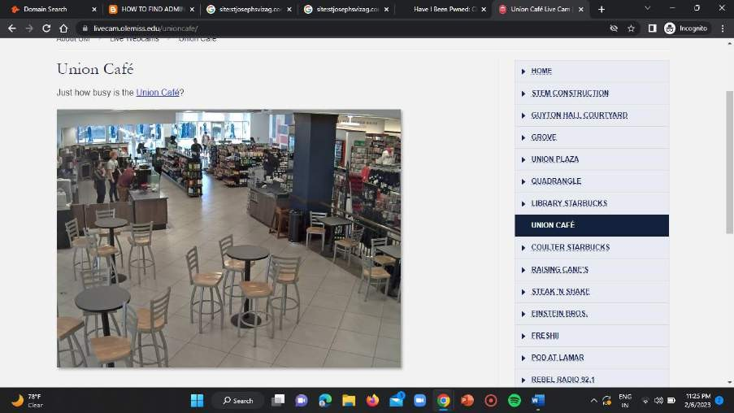

## CAM-7:

**LINK =** <https://livecam.olemiss.edu/einsteinbros/>

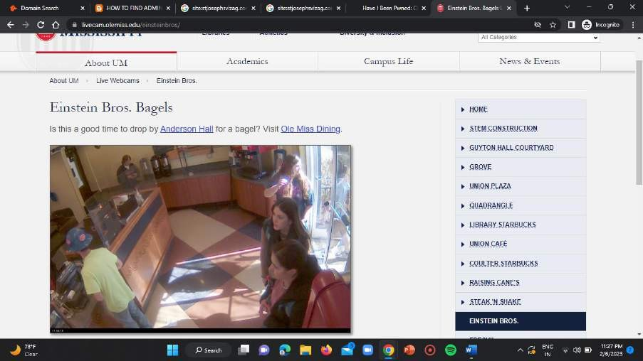

# CONCLUSION:-

So finally in this task segment we found the admin login pages of the given websites using footprinting technique. And we also gathered the 10 email addresses associated with any three of the given target domains and also we checked for the data breaches for all the emails we found in those domains. The last section of our task is about finding 7 webcams which are publicly available and connected to open networks and are live streaming and we

successfully found then using the footprinting technique.